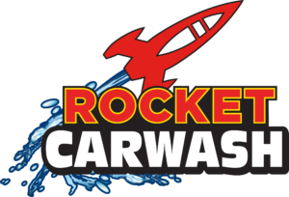

ROCKET CAR WASH

CLEAN YOUR CAR FOR A CAUSE

PLEASE SEE BELOW FOR DETAILS REGARDING HOW YOU CAN PARTNER WITH ROCKET CARWASH TODAY!
Company:
Rocket Carwash
Description:
- Purchase a Rocket Carwash for $10 ($24.99 value) and Rocket Carwash will donate $6 back to United Way of the Midlands.
- All carwashes purchased can be used at any Rocket Carwash location and are valid for 12 months.
- Washes are delivered automatically via text message and are giftable through any digital format.
- Sign up your company to partner with Rocket Carwash through your UWM representative.

