Workplace Campaign Email Templates
General Tips for Effective Donor Engagement
Subject Line: This is your first impression! Keep it short (under 50 characters), intriguing and relevant to your cause. Consider a question, a local reference or a sense of urgency that will resonate with your audience.
Personalize: If possible, address your donors by name. Segmentation tools in your email platform can help tailor your email messages as appropriate.
Highlight Local Impact: Showcase how you benefit the community by using local success stories, statistics, references and/or quotes from your team members.
Include a Clear Call to Action: Clearly state your call to action and make it easy for the recipient of your email message to complete that action (e.g., include a donation button).
Keep it Mobile-Friendly: Ensure your email messages display well on mobile devices, where many emails are opened. When possible, test messages on an Android and an iOS device.
Send Reminder Emails: Maintain a steady stream of support for your campaign by sending reminder emails at the appropriate times. Depending on the length of your campaign, we recommend sending one reminder email per week.
Donor Email Campaign Cadence
This document includes a recommended donor email campaign cadence that spans four key phases with sample, customizable copy for eight separate donor emails. Here is an overview of the cadence:
1: Welcome
2: Why United Way?
3: Reminders
4: Thank You

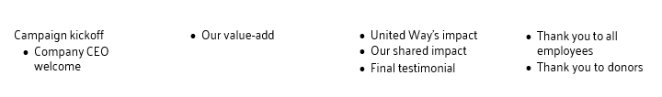

Phase 1: Welcome

Email 1a: Campaign Kickoff from United Way
From: Your CEO, Board or Campaign Chair’s first and last name
Audience: All company employees

Subject Line: Together, we’re building a stronger community
Email Copy:
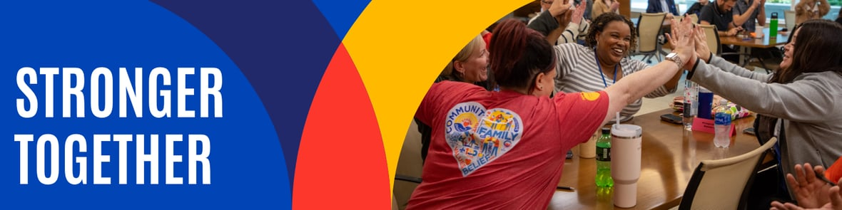

[First Name],

Time and again, we've seen neighbors, businesses and volunteers come together to support one another because it's simply the right thing to do. The Omaha-Council Bluffs metro is a community that cares for one another.
For more than 100 years, United Way of the Midlands has helped turn that caring spirit into results that make a difference. As families face rising costs and essential services experience growing demand, UWM remains a trusted partner — bringing people, resources and organizations together to strengthen our community.
Sometimes that means investing in more than 150 local programs Other times, it means operating direct services that fill critical gaps, connecting people to help through 211 or creating new opportunities for young people through JAG Nebraska. No matter how needs evolve, we're committed to ensuring help is there when it's needed most.
Because of you, we will help provide:
- 12 million meals
- 250,000 health services
- 175,000 shelter nights
- 50,000 education and training hours
When you give to United Way of the Midlands, you can give with confidence. Ninety-three cents of every dollar is invested back into our community, ensuring your generosity reaches our neighbors in need.
As we begin this year's campaign, I invite you to join us in strengthening our community. Together, we can continue providing immediate support, creating lasting opportunities and ensuring our neighbors have a trusted partner for whatever comes next.
[Button: Make Your Gift Today]

Email 1b: Company CEO Welcome
From: Company CEO, Leader, or Employee Campaign Chair’s first and last name
Audience: All company employees

Subject Line: [First Name], please join me in supporting United Way

Email Copy:
Hi [First Name],

At [COMPANY NAME], we believe in giving back to the community we call home. That’s why I’m proud to support United Way of the Midlands – and why I’m inviting you to join me.

United Way is a trusted partner that turns our care for the community into meaningful results by providing:
- Nutritious food and essential healthcare
- Childcare, early learning and opportunities for youth to reach their full potential
- Job training, financial assistance and housing support
- Emergency help through the 211 Helpline

With growing demands and new pressures on our support systems, your generosity can ensure help is there when it’s needed most. Let’s show what [COMPANY NAME] can do when we come together.

Join me — donate today!

Thank you for your commitment to making a difference.

Stronger Together,
[COMPANY CEO NAME]

[Button Text: Make Your Gift Today]

Phase 2: Why United Way?

Email 2: Our Value-Add
From: Your CEO, Board or Campaign Chair’s first and last name
Audience: All company employees

Subject Line: Stronger Together: Why Your Gift to United Way Matters

Email Copy:

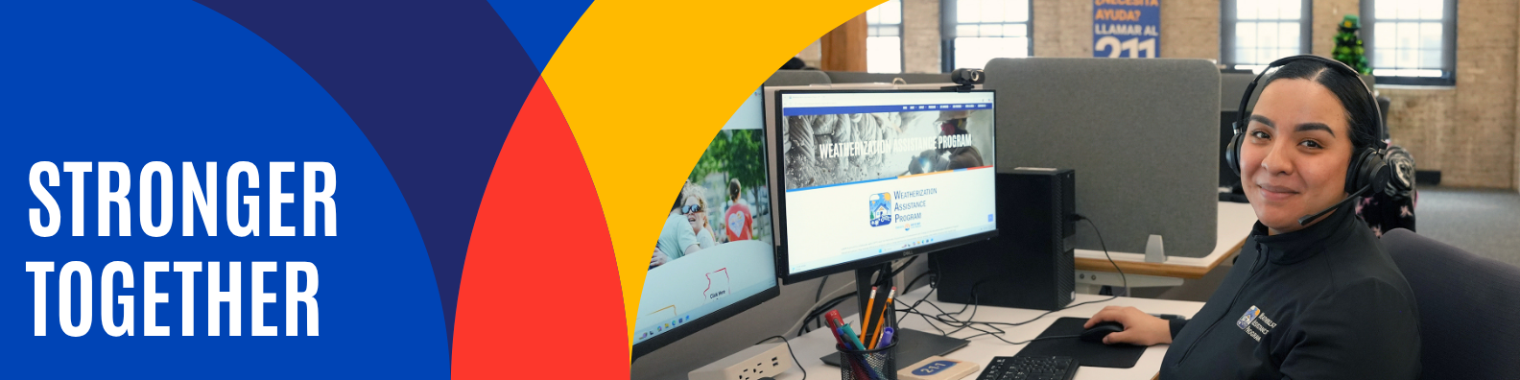

[NAME],
No one can predict what challenges tomorrow will bring. But together, we can ensure our community is ready to respond.
Across the Omaha-Council Bluffs metro, families continue to face rising costs and unexpected hardships.
- Nearly 20% of adults ran out of food before they could buy more.
- More than 7,500 young people are disconnected from work or school.
- 1 in 4 households can't afford a $400 emergency expense.
As needs continue to evolve, United Way of the Midlands remains a steady, trusted presence — bringing people, resources and organizations together to ensure help is there when it's needed most.
Your generosity strengthens a network of local programs and services that improve health and well-being, build financial security, create opportunities for young people and help our community respond to urgent needs.
Because of your support, over the next year we will help provide:
- 12 million meals
- 250,000 health services
- 175,000 shelter nights
- 50,000 education and training hours
As our community's needs continue to evolve, your support ensures our community has a trusted partner—today and for whatever comes next.
[Button Text: Make a Difference Today]

Phase 3: Reminders
Depending on the length of your campaign, we recommend sending one reminder email per week from kickoff to conclusion. Below are three sample emails, which can be customized to communicate compelling impact work and your unique relationship with the company you’re campaigning with.
- 3a. United Way’s Local Impact. The first reminder email template provides a platform for sharing your United Way’s holistic local impact. However, you can also tailor this to focus on just one area of your work that aligns most closely with your company’s impact/corporate social responsibility goals.

- 3b. Our Collective Impact. Use this template to highlight past partnerships with your company and employees, which could include volunteer activities or community projects.

- 3c. Final Reminder. You may choose to send this starting 10 days, one week or one day out from your campaign’s conclusion. It is important to close with a sense of urgency.

Email 3a: First Reminder – United Way’s Impact
From: Your CEO, Board or Campaign Chair’s first and last name
Audience: All company employees

Subject Line: [First Name] – see your local impact
Email Copy:
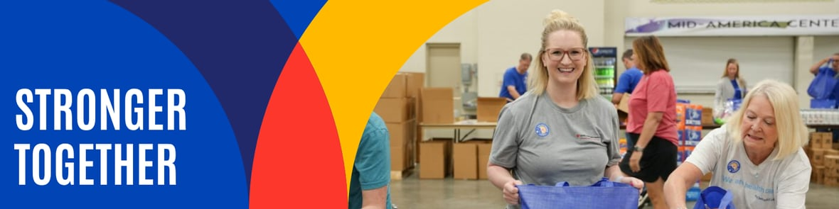
[NAME],

Whether you’re looking for new ways to get involved or have supported this work for years, your commitment is part of something powerful — a community of caring people like you, dedicated to making a difference. Your generosity supports individuals, families and a network of essential programs across the Omaha-Council Bluffs metro.
Together with you and [COMPANY NAME], we are addressing the metro’s most pressing needs:
- Helping more than 10,000 youth through programs like JAG Nebraska
- Providing 12 million meals to fight hunger
- Supporting 250,000 health services and 175,000 shelter nights
- Delivering $1 million in financial assistance to help families stay stable
These are real results for neighbors right here at home — families, kids and seniors working hard to overcome challenges.
If you’ve already made a gift, thank you! If you haven’t yet, now’s the perfect time to be part of something bigger.
Because our community thrives when we come together.

[Button Text: Get Involved]
Email 3b: Second Reminder – Our Shared Impact
From: Your CEO, Board or Campaign Chair’s first and last name
Audience: All company employees

Subject Line: Together, we’re stronger: [Company Name] Impact
Email Copy:
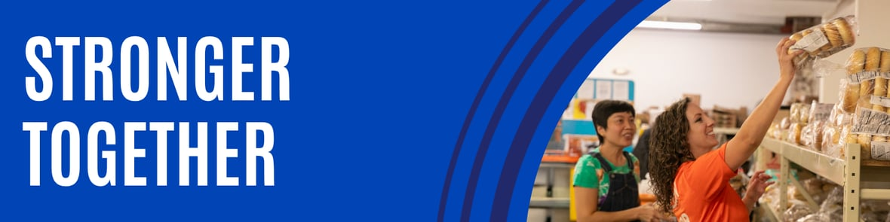

[NAME],

We are so grateful for the incredible partnership between [COMPANY NAME] and United Way of the Midlands. Together, we’ve helped strengthen the Omaha-Council Bluffs metro in so many ways.

[This email should be tailored to your relationship with UWM. We suggest:
- Highlight the number of years the company has been partnering with UWM
- Highlight the impact the company has had during your Day of Caring or Good on the GO events and the value of employee volunteerism to your community. Add photos, if you have releases.
- Has your company led holiday drives through UWM to benefit the community?
- Does your company have a number of hours of volunteerism to celebrate?]

Thanks to your generosity, [COMPANY NAME] has:
- Supported local volunteer projects like Shine Bright and Day of Caring
- Helped raise critical funds for 150+ programs and initiatives across the metro
- Provided hands-on support to neighbors in need
Our collective action sends a powerful message: when we show up for each other, we build a community where each of us can thrive.

Let’s make an even bigger impact this year.
[Button Text: Make Your Gift Today]

Email 3c: Third Reminder – Final Call with Beneficiary Testimonial
From: Your CEO, Board or Campaign Chair’s first and last name
Audience: All company employees
Subject Line: Last chance to make a difference today!
Email Copy:
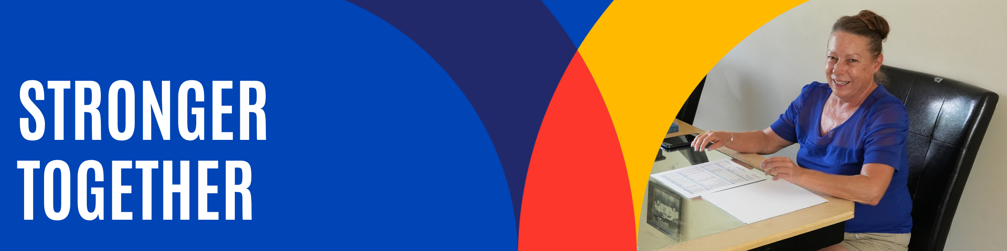

[NAME],
There's still time to make your gift through the [COMPANY NAME] United Way campaign before it ends on [DATE].

Every day, your generosity helps ensure people in our community have a trusted place to turn when they need support.

When Tracey's aging furnace, air conditioner and water heater made her home difficult to heat and cool, United Way's Weatherization Assistance Program helped make her home safer, more comfortable and more energy efficient with new equipment, insulation and other improvements.
"I am so grateful for everything done to my home to ease the burden of cooling and heating bills, plus the comfort and air quality it's added," Tracey shared.

Stories like Tracey's are possible because people like you choose to give.

Whether it's investing in local nonprofit programs, connecting someone to help through 211 or providing direct services that fill critical gaps, your support helps ensure our community has a trusted partner when it matters most.

Please make your gift by [DATE] and help keep that support within reach for families across our community.

[Button Text: Make Your Gift Today]

Phase 4: Thank You

Email 4a: General Thank You to All Employees
From: Your United Way CEO, Board or Campaign Chair’s first and last name
Audience: All company employees

Subject Line: [COMPANY NAME], thank you for your impact!

Email Copy:
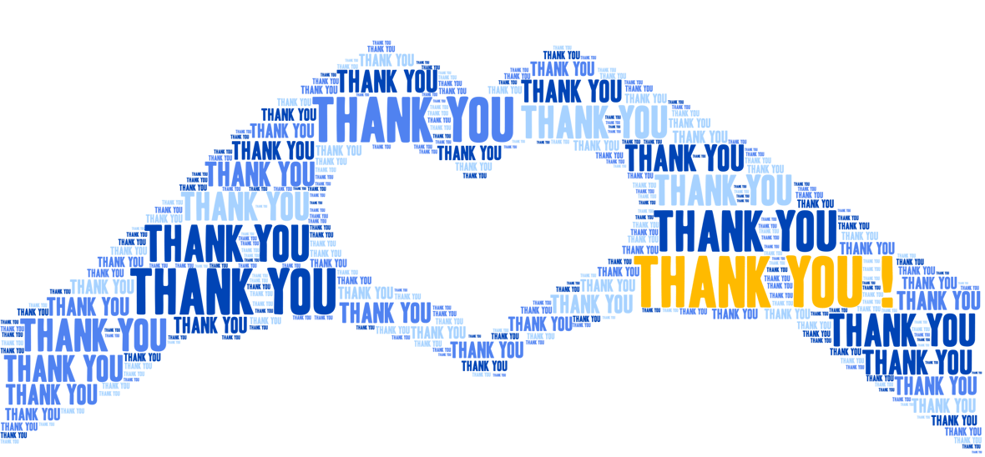
Dear [NAME],

Join me in celebrating the success of [COMPANY NAME] ‘s United Way employee giving campaign — a powerful example of what we can achieve together. Your gift reaches neighbors across our community and helps people move forward with hope and support. Because of you, local families are finding stability and getting the resources they need to thrive.
- $[DOLLARS PLEDGED] raised to support more than 150 programs, partnerships and community initiatives.
- [PARTICIPATION RATE]% employee participation
- [NUMBER OF DONORS] caring individuals making a difference
- [NUMBER OF VOLUNTEER HOURS] hours of time given to help others
But your impact doesn’t have to end here. There are so many ways to stay involved:
- Volunteer at a signature event — Help pack Shine Bright kits, join Day of Caring or support Holiday Helpers.
- Join a giving society — Connect with Bridgebuilder or Emerging Leaders members to network and drive change.
- Stay connected — Sign up for our newsletter to hear how your gift is working across the metro.
- Become an advocate — Tell others about local services like the 211 Helpline, Goodfellows or the United Housing Network.
Thank you for your generous gift. Your support is creating meaningful progress and strengthening the safety net for families across our community.
[Button Text: See Your Impact]

Email 5: Confirmation Thank You Email
From: Your United Way CEO/CPO, Board or Campaign Chair’s first and last name
Audience: Company employees who donated to United Way (not designated to other organizations)

Subject Line: [NAME], you made a difference – thank you!
Email Copy:

Dear [FIRST NAME],

Thank you for your generous gift to United Way of the Midlands! Your support delivers lasting impact across our metro, from strengthening local resilience to advancing health, youth opportunity and financial security. But your impact doesn’t have to end here. There are so many ways to stay involved!
- Volunteer at a signature event — Help pack Shine Bright kits, join Day of Caring or support Holiday Helpers.
- Join a giving society — Connect with Bridgebuilder or Emerging Leaders members to network and drive change.
- Stay connected — Sign up for our newsletter to hear how your gift is working in the metro.
- Become an advocate — Tell others about local services like the 211 Helpline, Goodfellows or the United Housing Network.
Thank you again for your incredible generosity! We are honored to help you make a difference — and show that we are Stronger Together.

[Button Text: Stay Involved]

